**TUTORIAL ROOM**

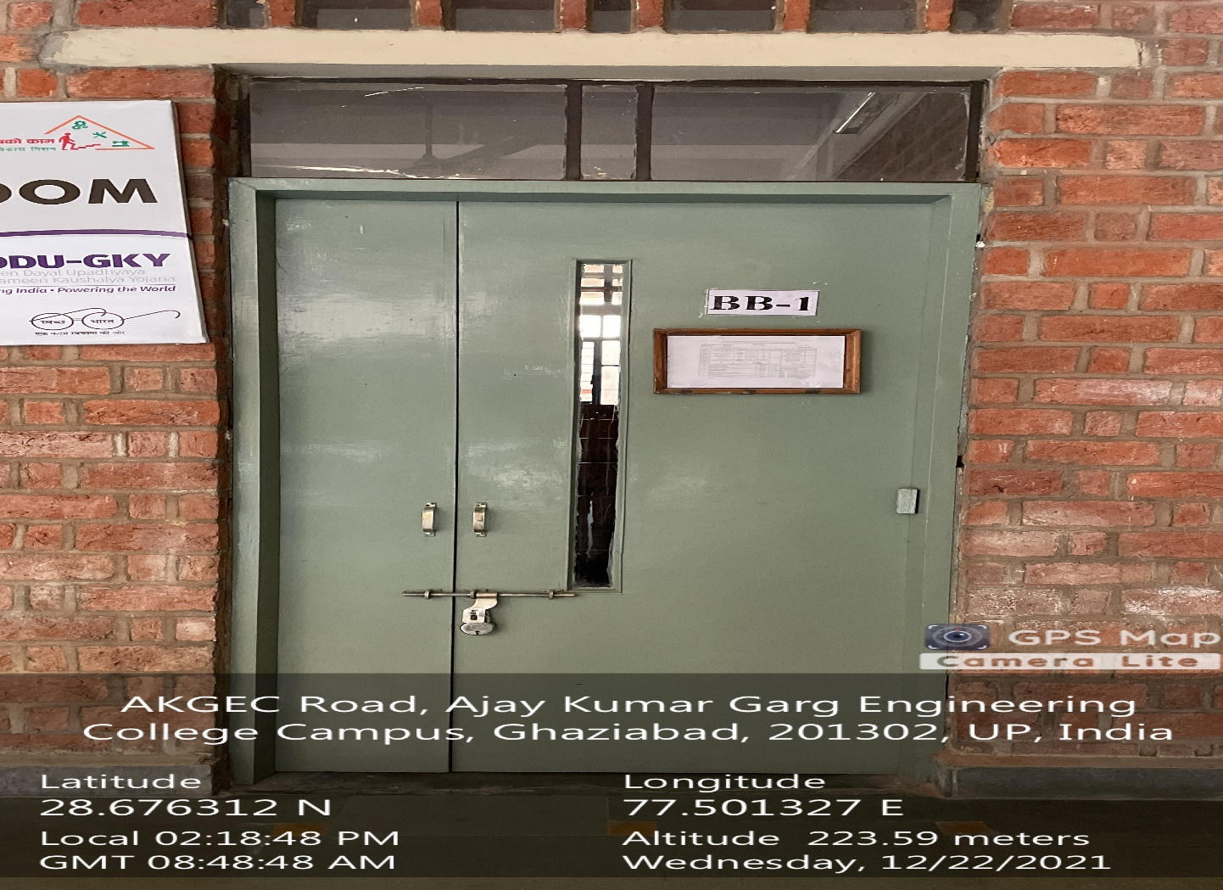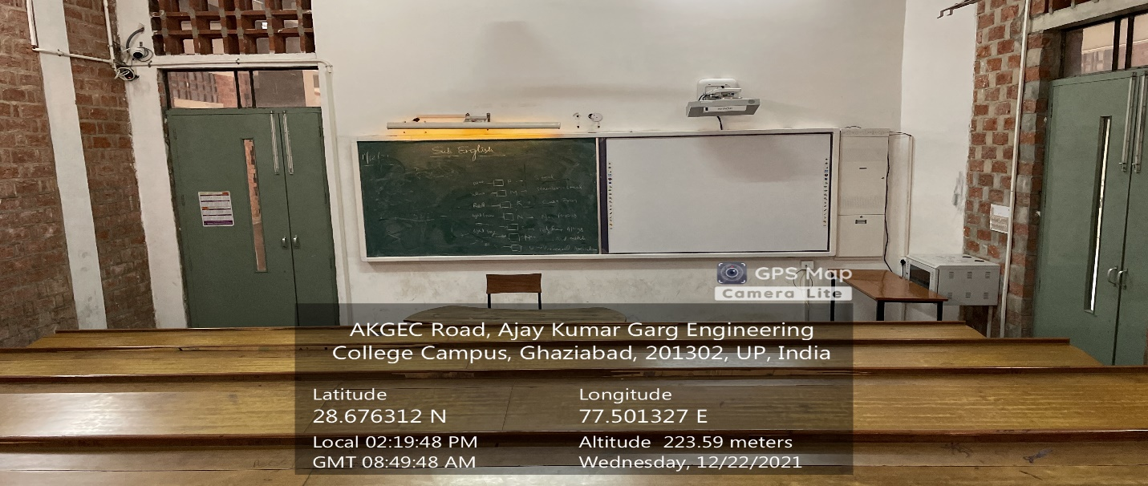**BB-1**

**(Back Block, Ground Floor)**

**(Available Facilities: Green Board, Smart Board Wi-Fi, Sound System)**

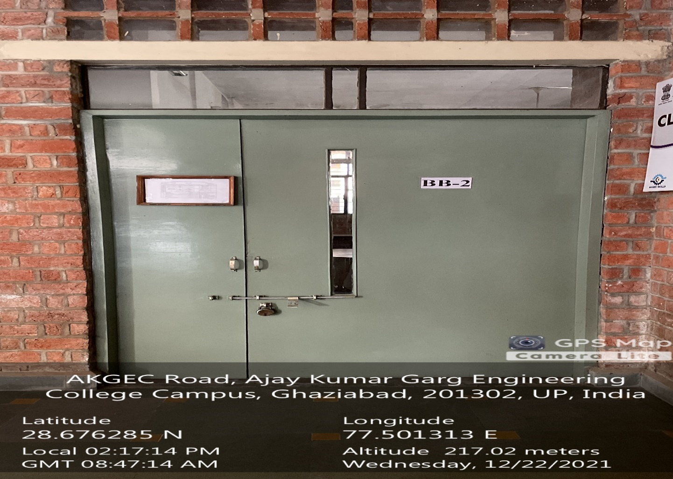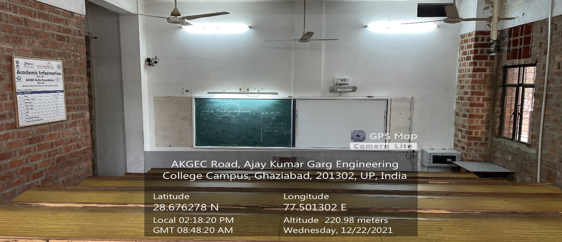 **BB-2**

**(Back Block, Ground Floor)**

**(Available Facilities: Green Board, Smart Board Wi-Fi, Sound System)**

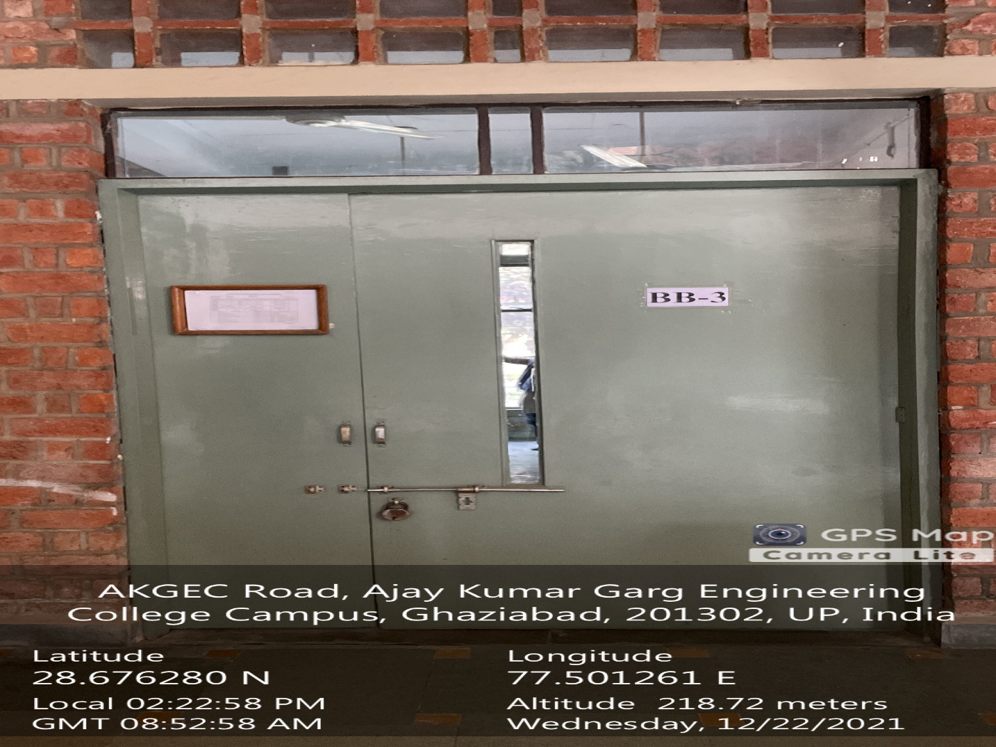**/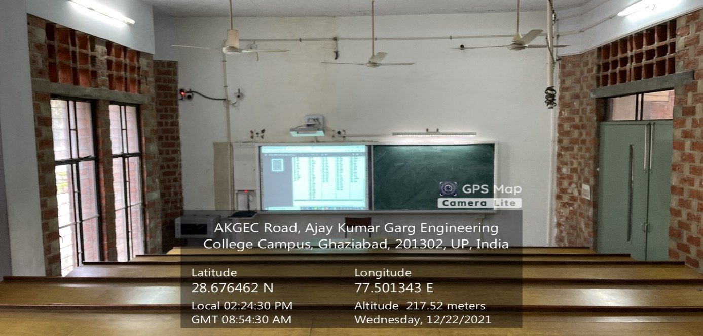 BB-3**

**(Back Block, Ground Floor)**

**(Available Facilities: Green Board, Smart Board Wi-Fi, Sound System)**

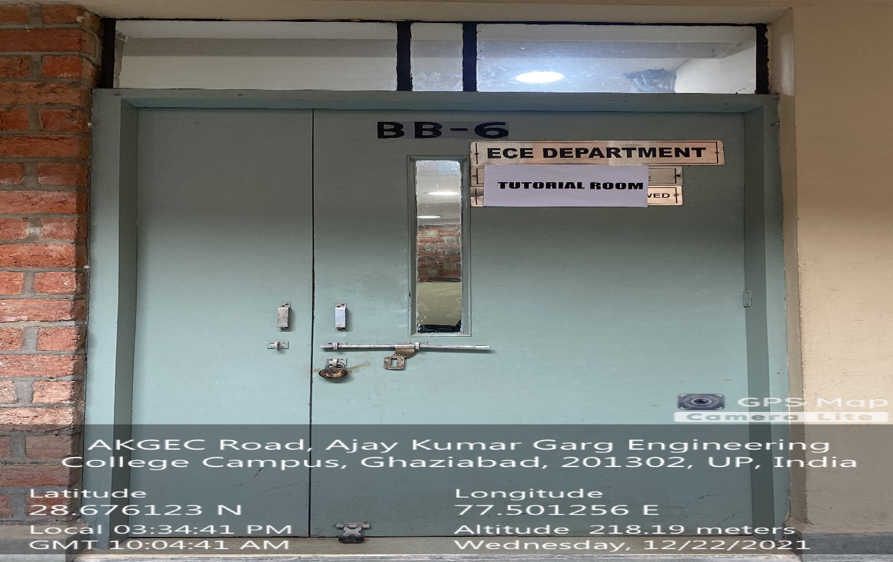

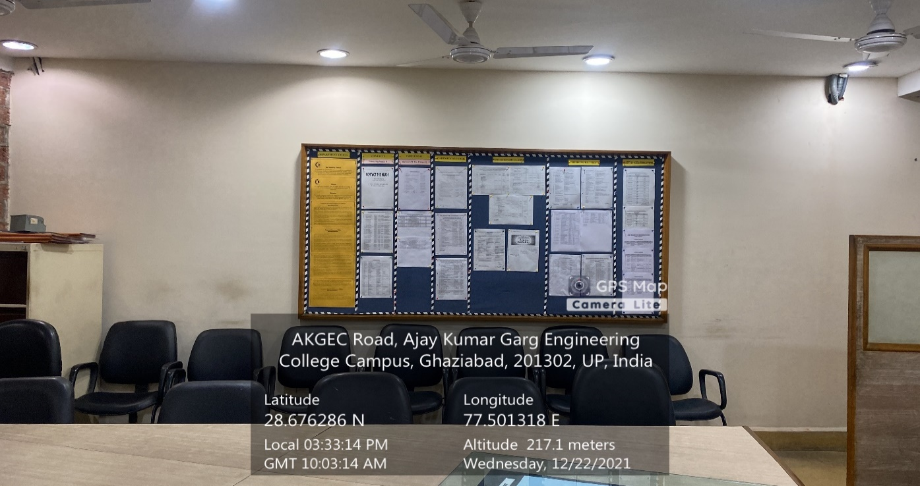

**TUTORIAL NO -2**

**(BACK BLOCK, SECOND FLOOR)**

**(Available Facilities: Projector, LAN, Wi-Fi, Sound System)**

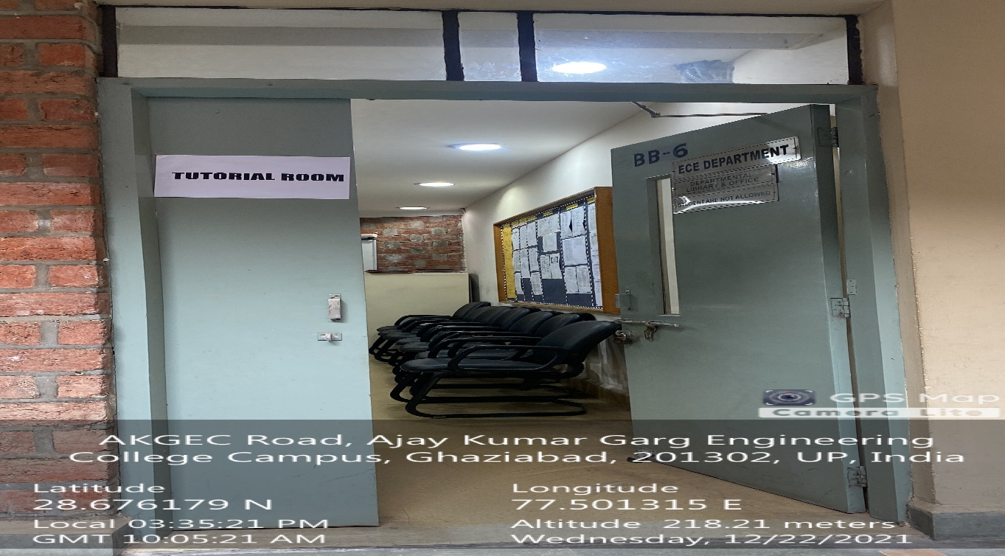

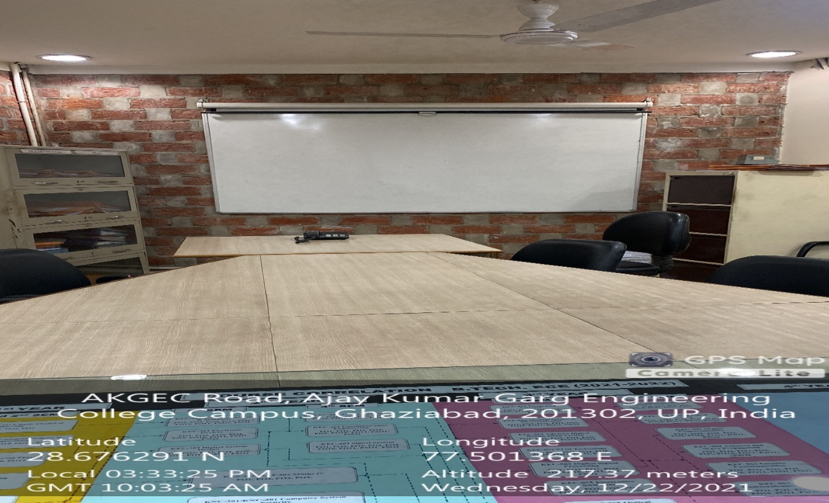

**TUTORIAL ROOM -7**

**(BACK BLOCK, FIRST FLOOR)**

**(Available Facilities: Projector, LAN, Wi-Fi, Sound System)**